Senior Design report

December 8, 2019

Design and implementation of a bionic prosthetic hand

Cybernetic solutions

Alexander Volkov, Jaesung Song

Faculty advisor: David Westerfeld

**Executive summary** **2**

**Background** **2**

**Customers and their Requirements** **3**

**Engineering specifications** **3**

**Design Concepts** **3**

EMG Sensor 4

Characteristics 4

Microcontroller 5

Motor 5

Wireless communication 7

Power supply 8

**Design Optimization** **8**

**Design Evaluation** **9**

Design, simulation and testing 9

**Conclusion and discussion** **15**

**References** **15**

**Appendix A** **16**

**Appendix B** **16**

#### 

#### Executive summary

The idea behind this project is to further the development of affordable bionic prosthetic limbs. In this case specifically, a generic bionic prosthetic arm will be developed that will have basic functions such as picking up and holding an object. The prosthetic arm will be controlled utilizing the electrical impulses created during the contraction of muscles. Reading of the muscle contractions will be done by placing electrode sensors on the skin and utilizing electromyography (EMG) technology. At a budget of $150 per student, it is essential that the prosthetic limb be cost efficient and affordable as well as fully functional.

This project will serve as a prototype for the implementation of an affordable bionic prosthetic arm rather than a finished product. As a result, the project will utilize one servo motor that will control the fingers simultaneously. Electrodes attached to the skin will detect electrical impulses from muscle contractions and will be sent through an amplifier. A custom circuit for EMG signal acquisition is going to be designed. The amplified and filtered signals will be rectified and analyzed by a microcontroller. In turn the microcontroller will determine if the motor needs to be activated.

#### Background

At the Applied Physics Laboratory located in the John Hopkins University, the Modular Prosthetic Limb (MPL) claims to be the most advanced bionic prosthesis in development. This bionic limb can serve as a reference in our project to view the high end specs and future possibilities of prosthesis. To sense electrical impulses within muscle tissue various technology is used such as implanted intramuscular electrodes, peripheral nerve and cortical electrodes, often in conjunction with surface electrodes. Other implementations of bionic prosthetic may not be utilising as high end technology but instead focus on delivering rather affordable device.

Open bionics developed the “Hero Arm” - an affordable bionic prosthetic limb controlled with your muscles, with “intuitive lifelike precision”. It utilises 3D printing technology to reduce the costs and comes with 4 to 6 different grip patterns depending on the model of the arm. The device uses EMG sensors installed in the arm to sense muscle contractions. The electrodes are placed on the muscle group responsible for opening and closing biological hand. Then the intensity of contraction determines the speed of grip opening/closing that allows extra control when working with small or delicate objects. Our implementation will be a simpler version of the Hero Arm due to budget and time constraints.

#### Customers and their Requirements

The targeted user base for this project are generally going to be amputees from low/middle class families. There are no technical or physical requirements from the user. The resulting project should yield an intuitive and simple design. Anybody should be able to use the product regardless of their background.

#### Engineering specifications

Engineering specifications are targets that our project is aiming to implement. It’s important to have a list of definite requirements that allows our product to provide an easy and intuitive experience to the end user. Below is the list of end specifications to attempt to achieve and/or improve on:

* Hand gestures: 1
* Freedom of movement (Finger Joints): 90 Degrees
* Signal Delay 0.5 seconds
* Cost Range $200-$300
* Weight: Under 2 lbs
* Grip strength: 1 lbs
* Battery Life: 8 hours
* Charging via USB
* MCU: TI MSP Ultra-Low-Power

#### Design Concepts

The original concept for the project was a 3-D printed prosthetic arm with 4 fingers and 1 thumb each of which being controlled by their own individual motors. After a bit of discussion, it was concluded that with the small team and the minimal budget being provided, there is no way to properly develop a prosthetic arm with 5 independently moving fingers. It was decided that by having 1 motor control the fingers the cost will remain within the given budget levels. The simplest way to evaluate the final project is to have it grab onto an object when a user makes a hand gesture. The final product should have a firm grasp on the object. The object should not be easily removed from the arm and will be released when the user makes another hand gesture. An additional wireless signaling feature can be added in if it fits within the budget. Further is a more in depth information researched on the parts required and available options for purchase.

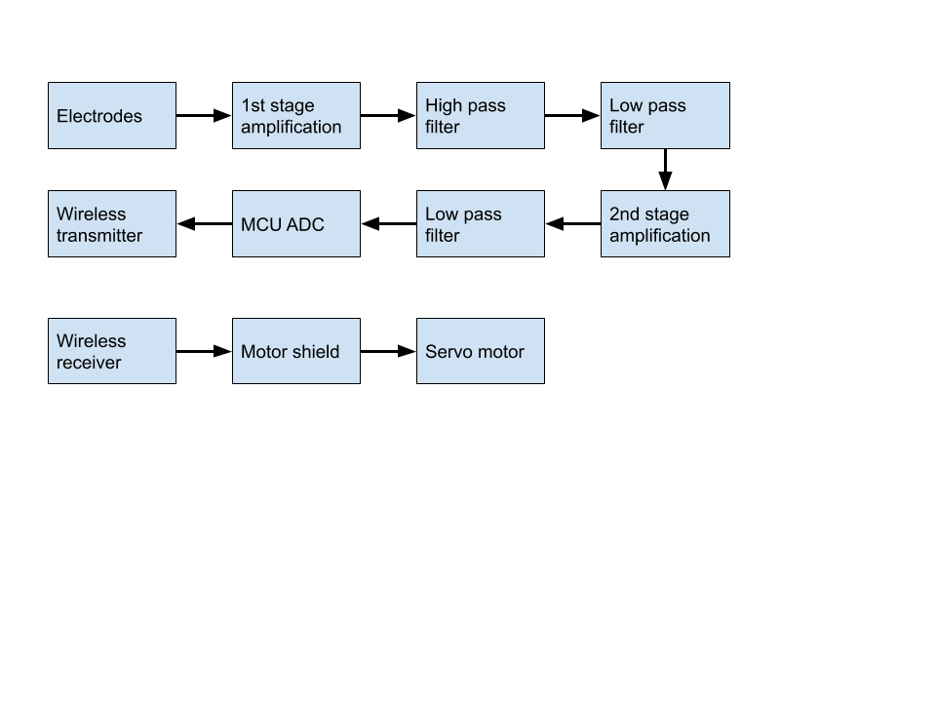

Figure 1: Block diagram

##### EMG Sensor

Electromyography is the study of muscle function through analysis of the electrical signals emanated during muscular contractions. Small electrical currents are generated by muscle fibres prior to the production of muscle force. Those currents can be recorded and measured which allows us to detect muscle contractions. The motor unit is the most elementary functional unit of a muscle, when activated it’s generating a motor unit action potential (MUAP). Repeated activation created action potential trains that are superimposed as EMG signal. The pick-up area of an electrode will almost always include more than one motor unit because muscle fibers of different motor units are intermixed throughout the entire muscle. Any portion of the muscle may contain fibers belonging to as many as 20-50 motor units. [2]

###### Characteristics

The EMG spectrum includes signals with frequencies varying from 1 Hz to 1 kHz, primarily between 50 and 150 Hz, and voltage peaks going from up 1 µV to 100 mV, mainly between 50 µV and 9 mV [3]. While fine wire electrodes can pick up full range of frequencies, surface electrodes have a bandwidth of 10-600 Hz. Using the Nyquist Theorem, this means that one must sample at a minimum of 1,200 Hz for surface electrodes and 2,000 Hz for fine wire electrodes in order to assure capturing the entire signal. There is always an error that's based on the resolution of ADC. Most of the analog to digital converters are of only 10-12 bits and if the system is not utilizing the full collected range it will induce an error. Thus the system needs to be designed to output only useful EMG signal that has been amplified to use all of the collection range.

##### Microcontroller

There are countless possible options of Microcontrollers that can be used for this project. The main goal for this project is to develop a cheap functional prosthetic, so the most important factors in deciding a microcontroller are the price and power consumption of the controller. Texas Instruments MSP430FR5969 has an ultra-low power mode which is perfect for the application in this project. MSP430 is a series of Texas Instruments MCUs that utilize an ultra low power mode. This ultra low power mode takes advantage of the high speed of 64kb of FRAM to create an almost instantaneous wake up time for its “active” and “sleep” mode. This is paired with an innate power consumption monitoring software known as Energia. Energia can separate the power levels based on the different tiers of low power mode that the MCU is in. This will make it easy to determine whether the system is running at optimal capacity. The MCU comes with 12 ADC converters that can be operated with interrupts. This is incredibly useful for decreasing power consumption as it will only change power modes based on signal noise.

##### Motor

A motor we have chosen for this project is TowerPro MG995. It’s a quite powerful servo motor that produces a lot of torque and has a low cost. On the other hand it can be slow and inaccurate. It can be difficult to get this motor into a desired angular position as it tends to overshoot.

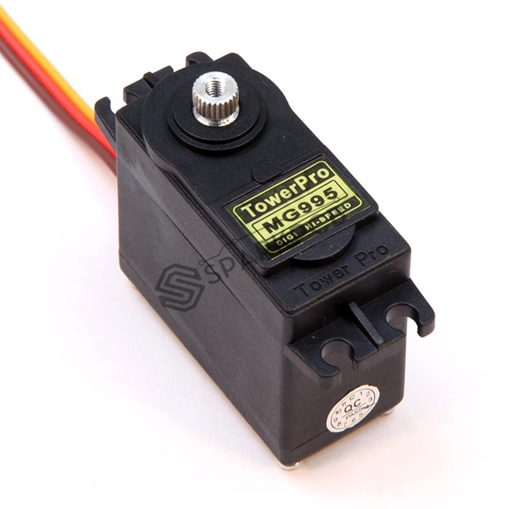

Figure 6. TowerPro MG995 servo motor

Here are some specifications of this motor:

| Modulation | Digital |
| --- | --- |
| Torque: | 4.8V: 130.54 oz-in (9.40 kg-cm)  6.0V: 152.76 oz-in (11.00 kg-cm) |
| Speed: | 4.8V: 0.20 sec/60°  6.0V: 0.16 sec/60° |
| Weight: | 1.94 oz (55.0 g) |
| Dimensions: | Length:1.60 in (40.7 mm)  Width:0.78 in (19.7 mm)  Height:1.69 in (42.9 mm) |
| Motor type: | 3 pole |
| Gear Type: | Metal |

This motor will be powerful enough to actuate all 5 fingers at once. Another option is to use TowerPro MG930. It’s a servomotor from the same family but smaller in size, with a mass less than half that of TowerPro MG995. Consequently this comes with lower torque but if we use these motors to only move one finger per motor we believe it might work. However this design was decided to be attempted as an improved version only after making the first prototype functioning successfully. Here are some specifications of this motor:

| Modulation | Digital |
| --- | --- |
| Torque: | 4.8V: 50.0 oz-in (3.60 kg-cm)  6.0V: 62.5 oz-in (4.50 kg-cm) |
| Speed: | 4.8V: 0.14 sec/60°  6.0V: 0.11 sec/60° |
| Weight: | 0.92 oz (26.0 g) |
| Dimensions: | Length:1.43 in (36.2 mm)  Width:0.60 in (15.2 mm)  Height:1.13 in (28.7 mm) |
| Rotation: | Dual bearings |
| Gear Type: | Metal |

##### Wireless communication

There are a few types of wireless communications that can be utilized for this project. These include Bluetooth, Bluetooth Low Energy (BLE), Zigbee, and Z-Wave. After careful consideration, it was decided that both Zigbee and BLE must be tested to fully optimize the project. The main factor for this decision is the low power consumption of ZigBee as compared to all the other communications other than BLE. BLE has the lowest power consumption, but these low power consumption levels are only achieved in specific situation due to its “sleep” and “active” modes. The biggest problem that arises is the fact that Zigbee has a significantly lower throughput than BLE by about four times. BLE’s 1 Mbit/s throughput is more practical to use than Zigbee’s 250Kbit/s. If the throughput is too low, then the prosthetic arm will not be able to properly process the signals being transmitted. Therefore, we will use BLE as it is the simplest and easiest to implement. BLE is also the most commonly used form of wireless communication so it would be optimal for general usage. After careful consideration, the nRF52832 was chosen as the proper development kit. This kit is developed by Nordic Semiconductors and is designed specifically for Bluetooth Low Energy. This kit supports the latest version of BLE, Bluetooth 5.0. It also is a System on Chip kit (SoC). SoC means that the kit comes with a fully functioning system, so there will be no need to buy extra parts for transmitting and receiving the signals.

##### Power supply

Our project has two independent circuits. First circuit is responsible for acquiring input signal and processing it. It consists of the EMG sensors, amplifiers, filters, an ADC, a microcontroller, and a wireless communicator. Second circuit is the robotic arm that has a wireless receiver, a simple microcontroller for processing the signal, a motor controller, and a servo motor. The EMG signal acquisition circuit will be powered by Lithium-Ion rechargeable battery. With the use of a buck-boost regulator a 5 V power rail can be created. Signal conditioning circuit will be using +/- 5V with the reference linked to the ground. For that purpose a simple DC to DC switched capacitor regulator is utilized. The MSP430 microcontroller operates on 3 V power supply so a DC to DC step down regulator will be implemented in the next version of our prototype in spring semester. The motor is powered with 5V that can be achieved the same way with a buck-boost regulator.

#### Design Optimization

The essential distinction that this project is making from other prosthetic limbs is that it is cheap, but also has the basic functionality such as opening and closing the hand. The reason most prosthetics are incredibly expensive is because each limb must be created and customized by a highly skilled professional and more advanced models require many expensive components. Most advanced prosthetics have very expensive parts that allow for a very precise movement of robotic arm in response to user’s input. One way to significantly reduce the cost is by having a 3-D printer produce the prosthetic limb instead. Ultra low power MCUs, cheap but less accurate servo motors, and inexpensive/lightweight material for 3-D printing will contribute to making an inexpensive yet functional arm. All of these factors can help contribute to the cost barrier that prevents the average handicapped individual from purchasing a functional prosthetic. This would greatly improve their quality of life which would remove many social stigmas of not having a limb. Some of the potential improvements to consider are to use extra motors in order to add individual finger movements and add extra electrodes for an improved hand control. Depending on the time of completion of the prototype these improvements will be reviewed and considered to be added to our prototype next semester.

#### Design Evaluation

There are three designs that were considered. The first of these designs was a fully functional arm with 5 different motors for each of the fingers in the prosthetic arm. This design was proved to be unviable for this project due to the low budget conflicting with the cost of the motors. The second design is a slight modification of the first design. By connecting 4 fingers to one motor, costs can be significantly decreased. The final agreed upon design is a simplification of the 2 previous designs. It has 1 motor to control all 5 fingers to minimize material/motor costs and simplifies the coding of hand patterns. Reducing complexity in the design will also decrease weight which will in turn decrease power consumption of the device. Second design may be implemented in case of successful implementation of our current design and sufficient time availability.

##### Design, simulation and testing

The following part was developed by Alexander Volkov. After conducting research on existing implementations of the signal acquisition circuit we’ve designed our own circuit for signal processing with an emphasis on noise treatment. The simulation analyzes 10 Hz, 250Hz, 700Hz and 5kHz input frequencies. To be able to use a microcontroller to interpret this signal we need to amplify, filter and rectify it. Our implementation has 4 stages: 1st stage - initial signal amplification using an instrumental amplifier INA128 with a gain of about 200, 2nd stage - low pass filter with cut-off frequency of 700 Hz, 3rd stage - high pass filter with cut-off frequency of 50 Hz, 4th stage - 2nd signal amplification followed by rectification. Signal is stabilized with a peak detector. Gain of the instrumental amplifier INA128 is defined as G=1*50 Ohm/Rg , so with Rg = 240 Ohm the gain is equal to 207. That’s enough to amplify 50uV to 10mV.

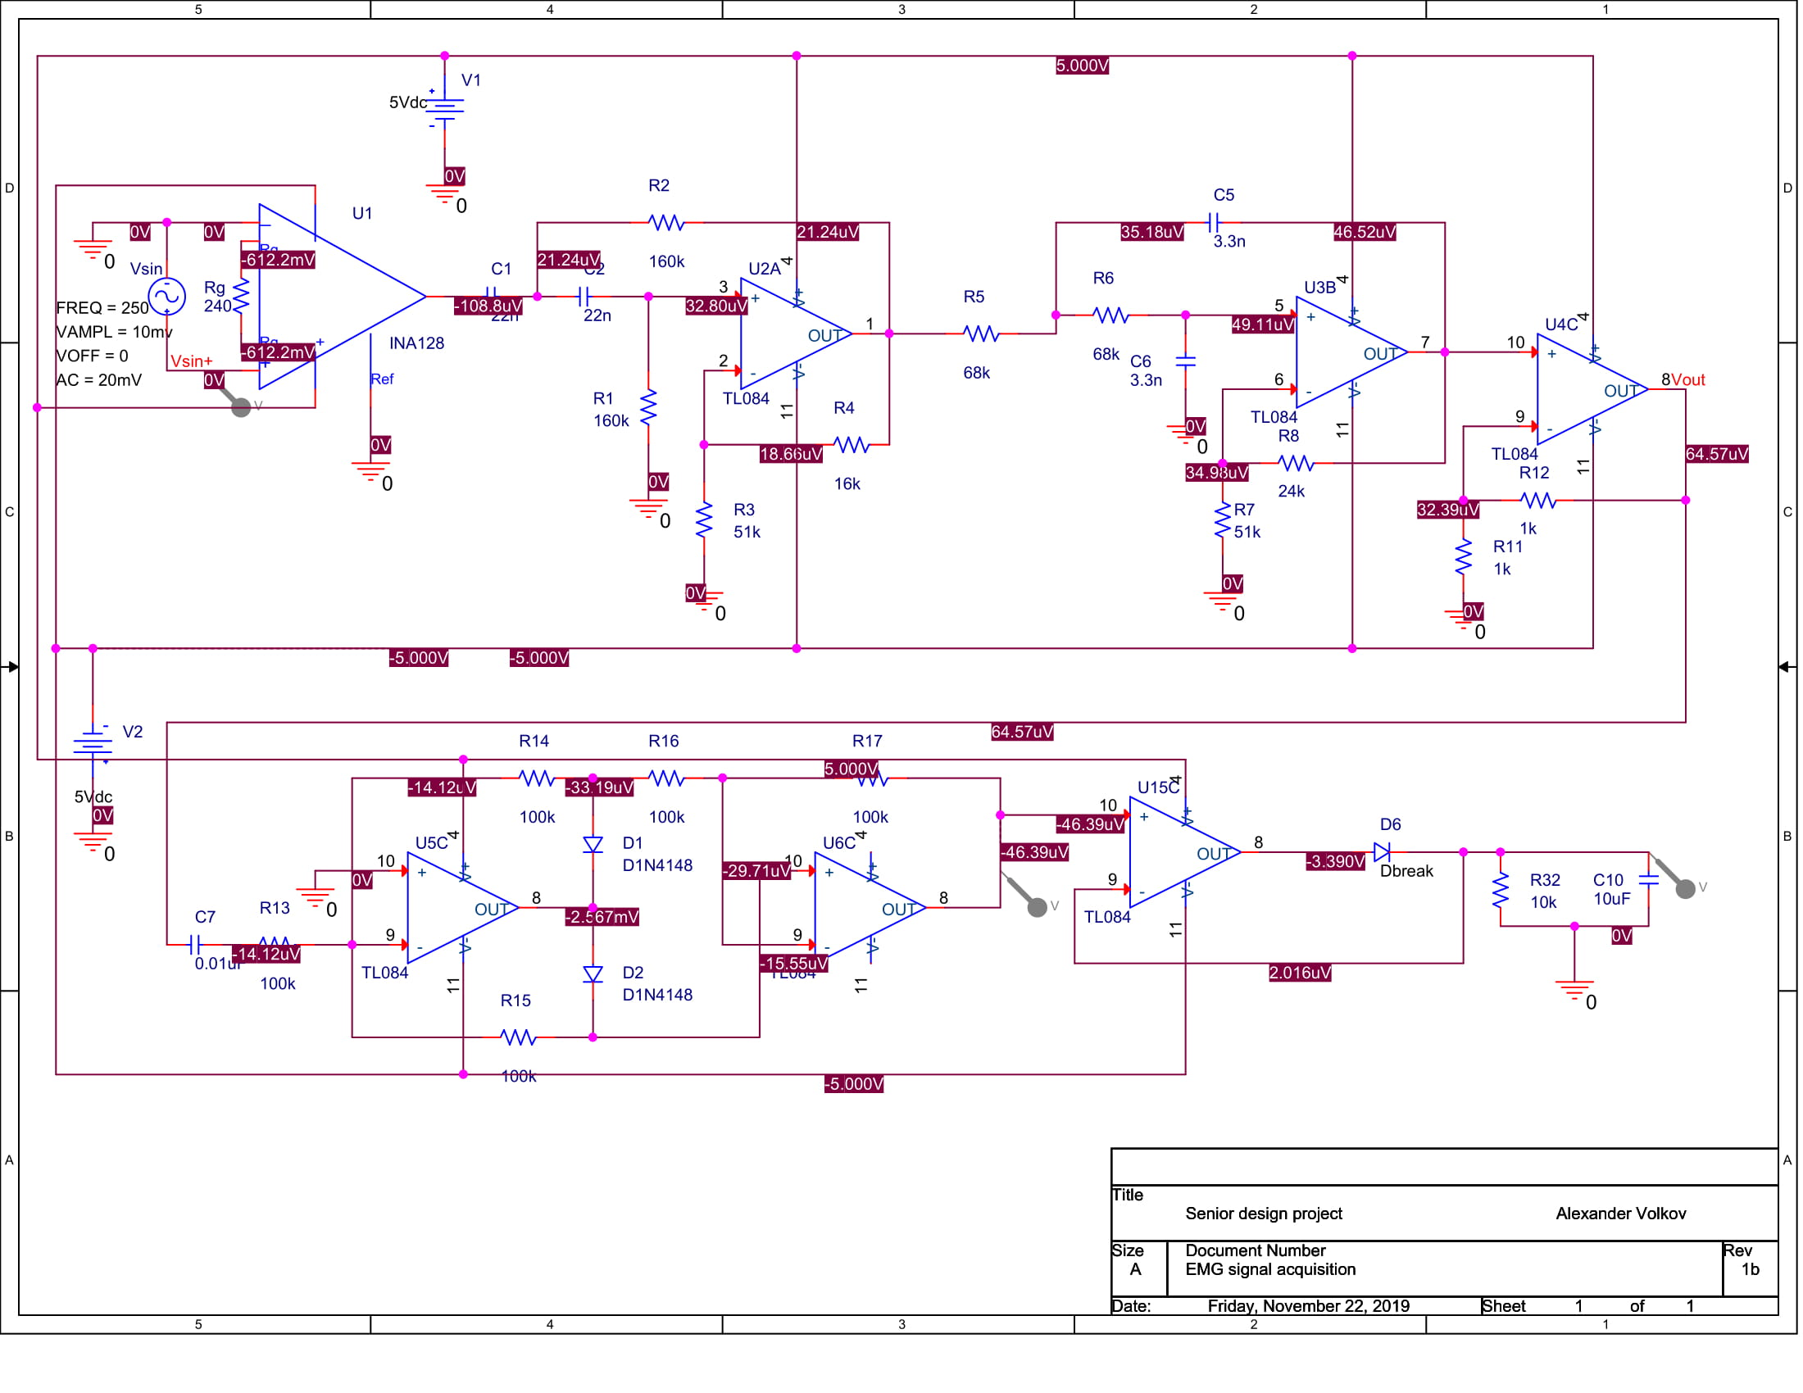

Figure 1: OrCAD simulation circuit configuration

The input signal of the circuit is coming from a sine wave signal generation with adjustable frequency and amplitude. Firstly a sine wave with frequency of 250 Hz is analyzed. The amplitude of the wave is equal to 10 mV, which is close to the peak amplitude of the EMG signal. The simulation results (Figure 2) show the output signal to stabilize at 2.86 V which is close to the max value of 3 V of the microcontroller’s ADC. The gain of the circuit is equal to 2860.

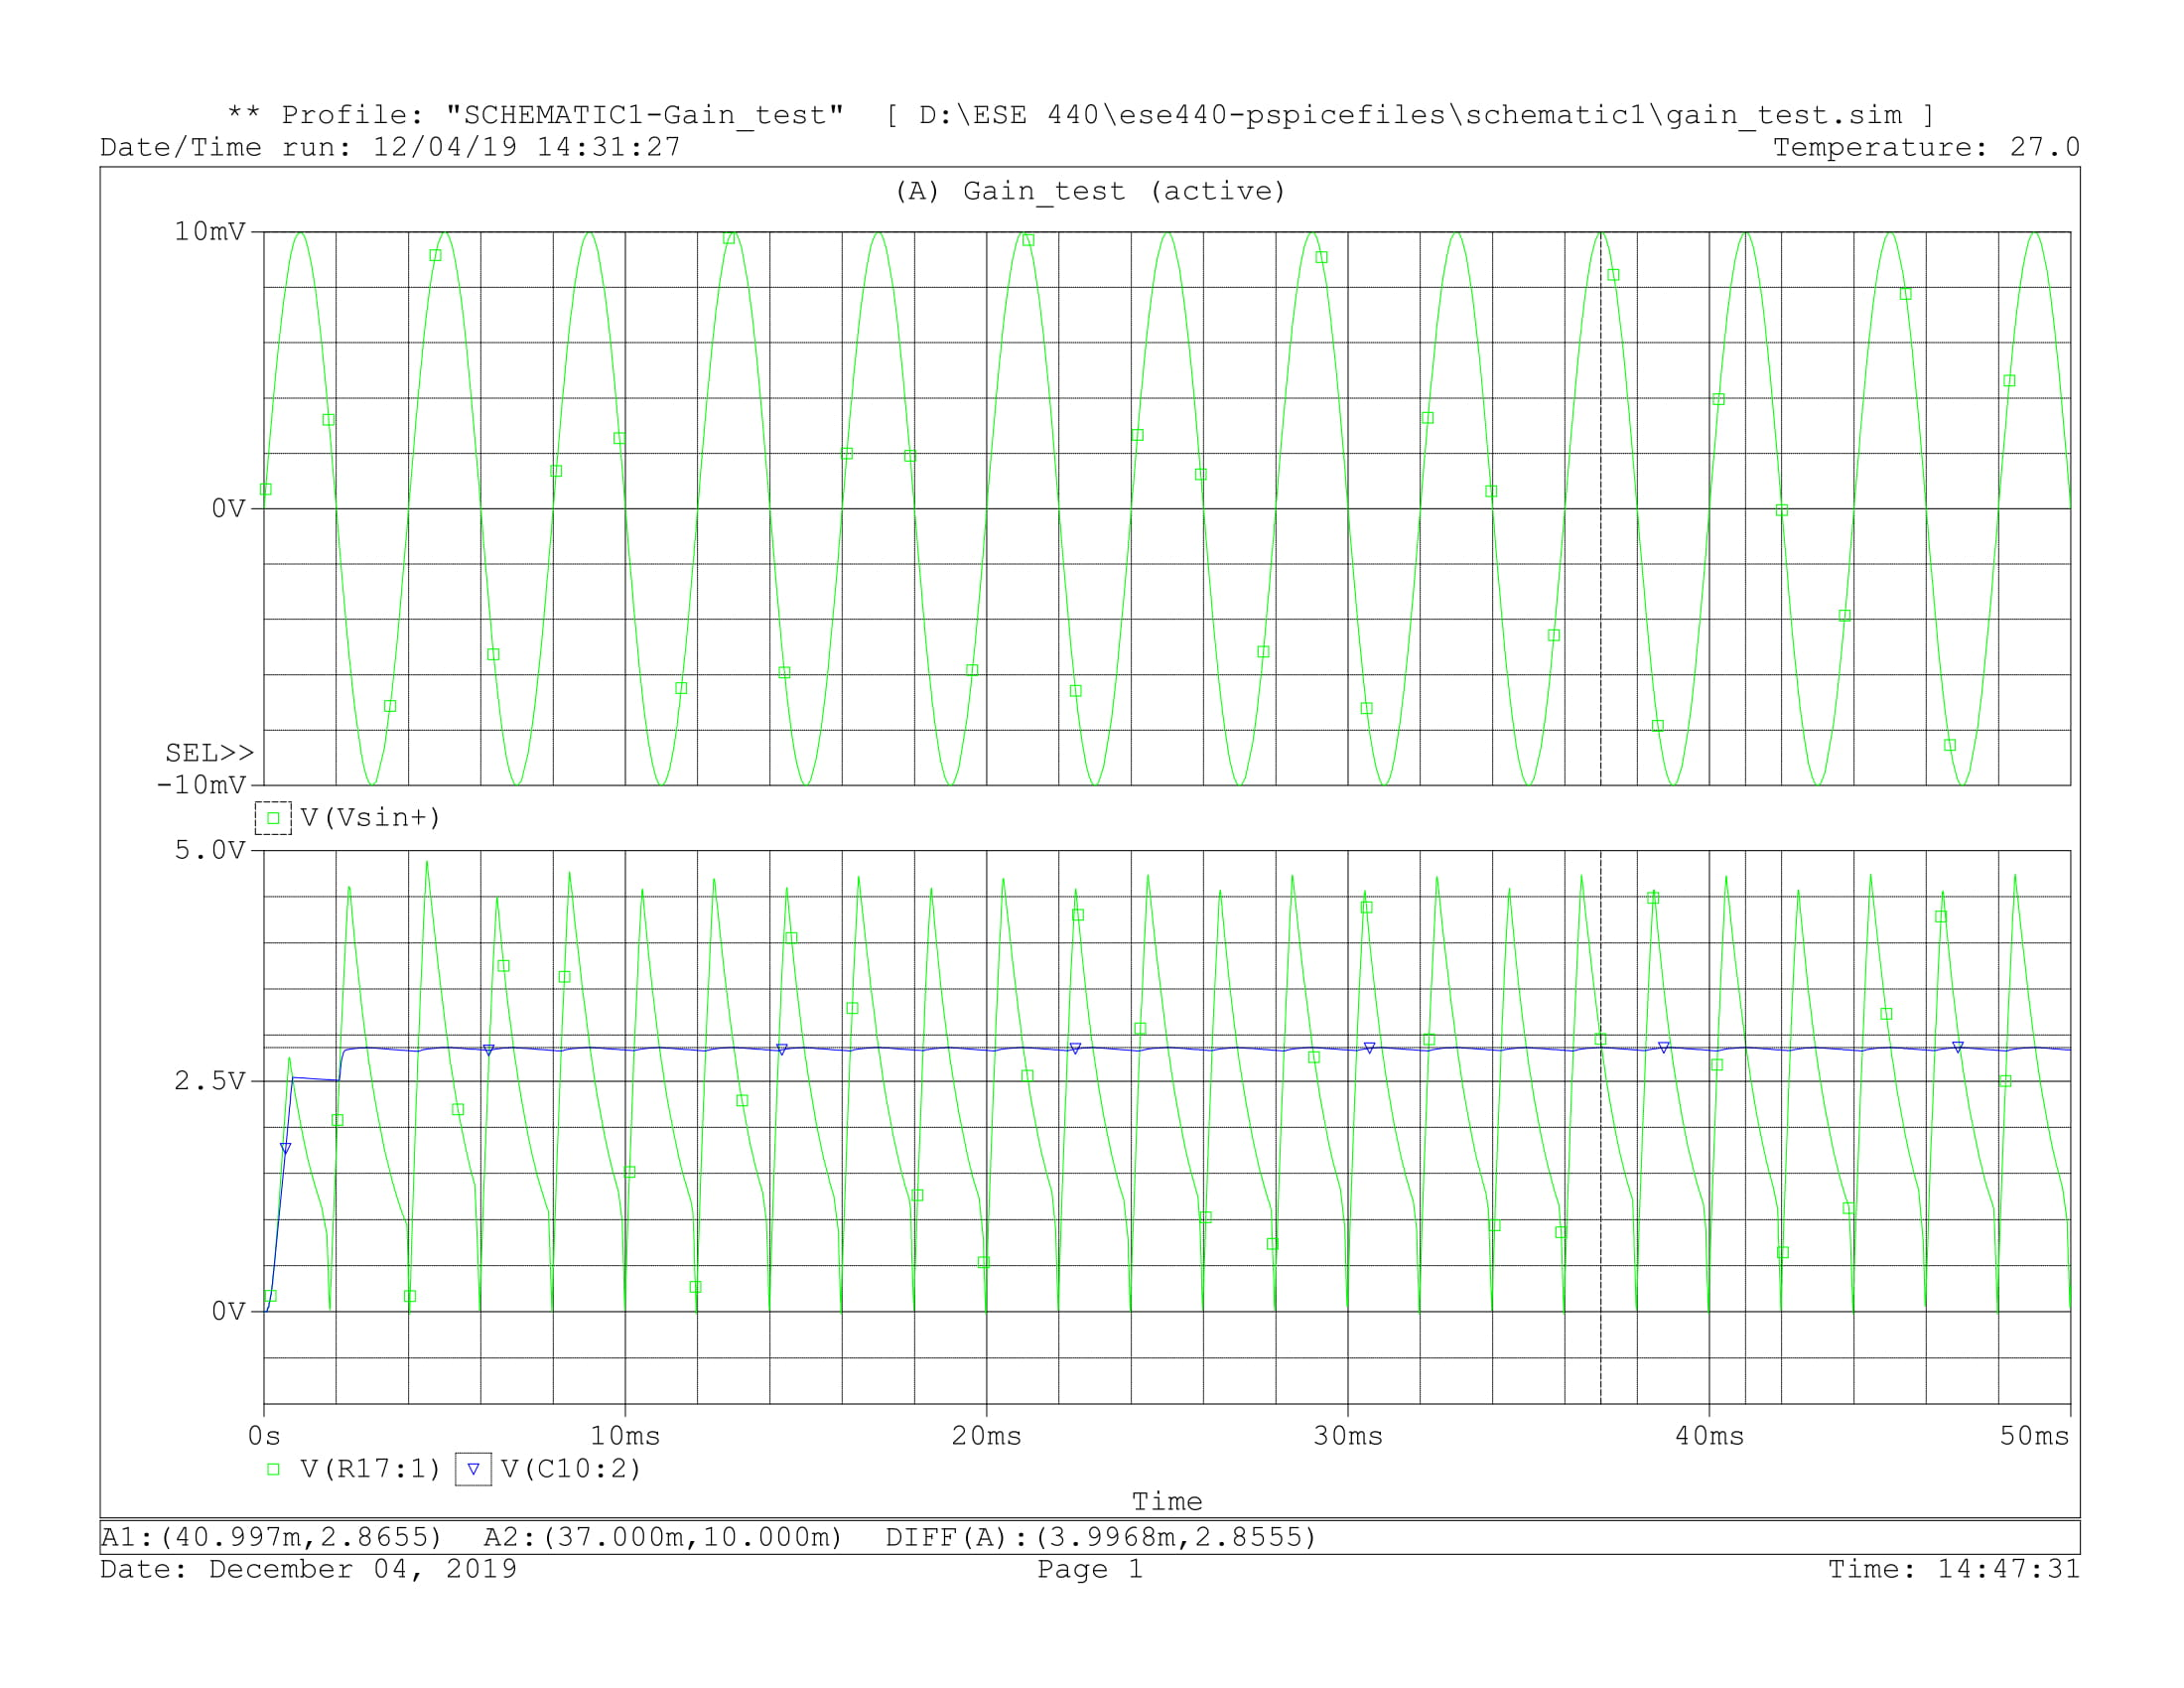

Figure 2: Simulation for 250 Hz input

For an input of 10 Hz the circuit’s output has a very low value, only twice the amplitude of the input signal. This means that the signal that doesn’t fall into the range of useful frequencies of EMG signal was successfully filtered out.

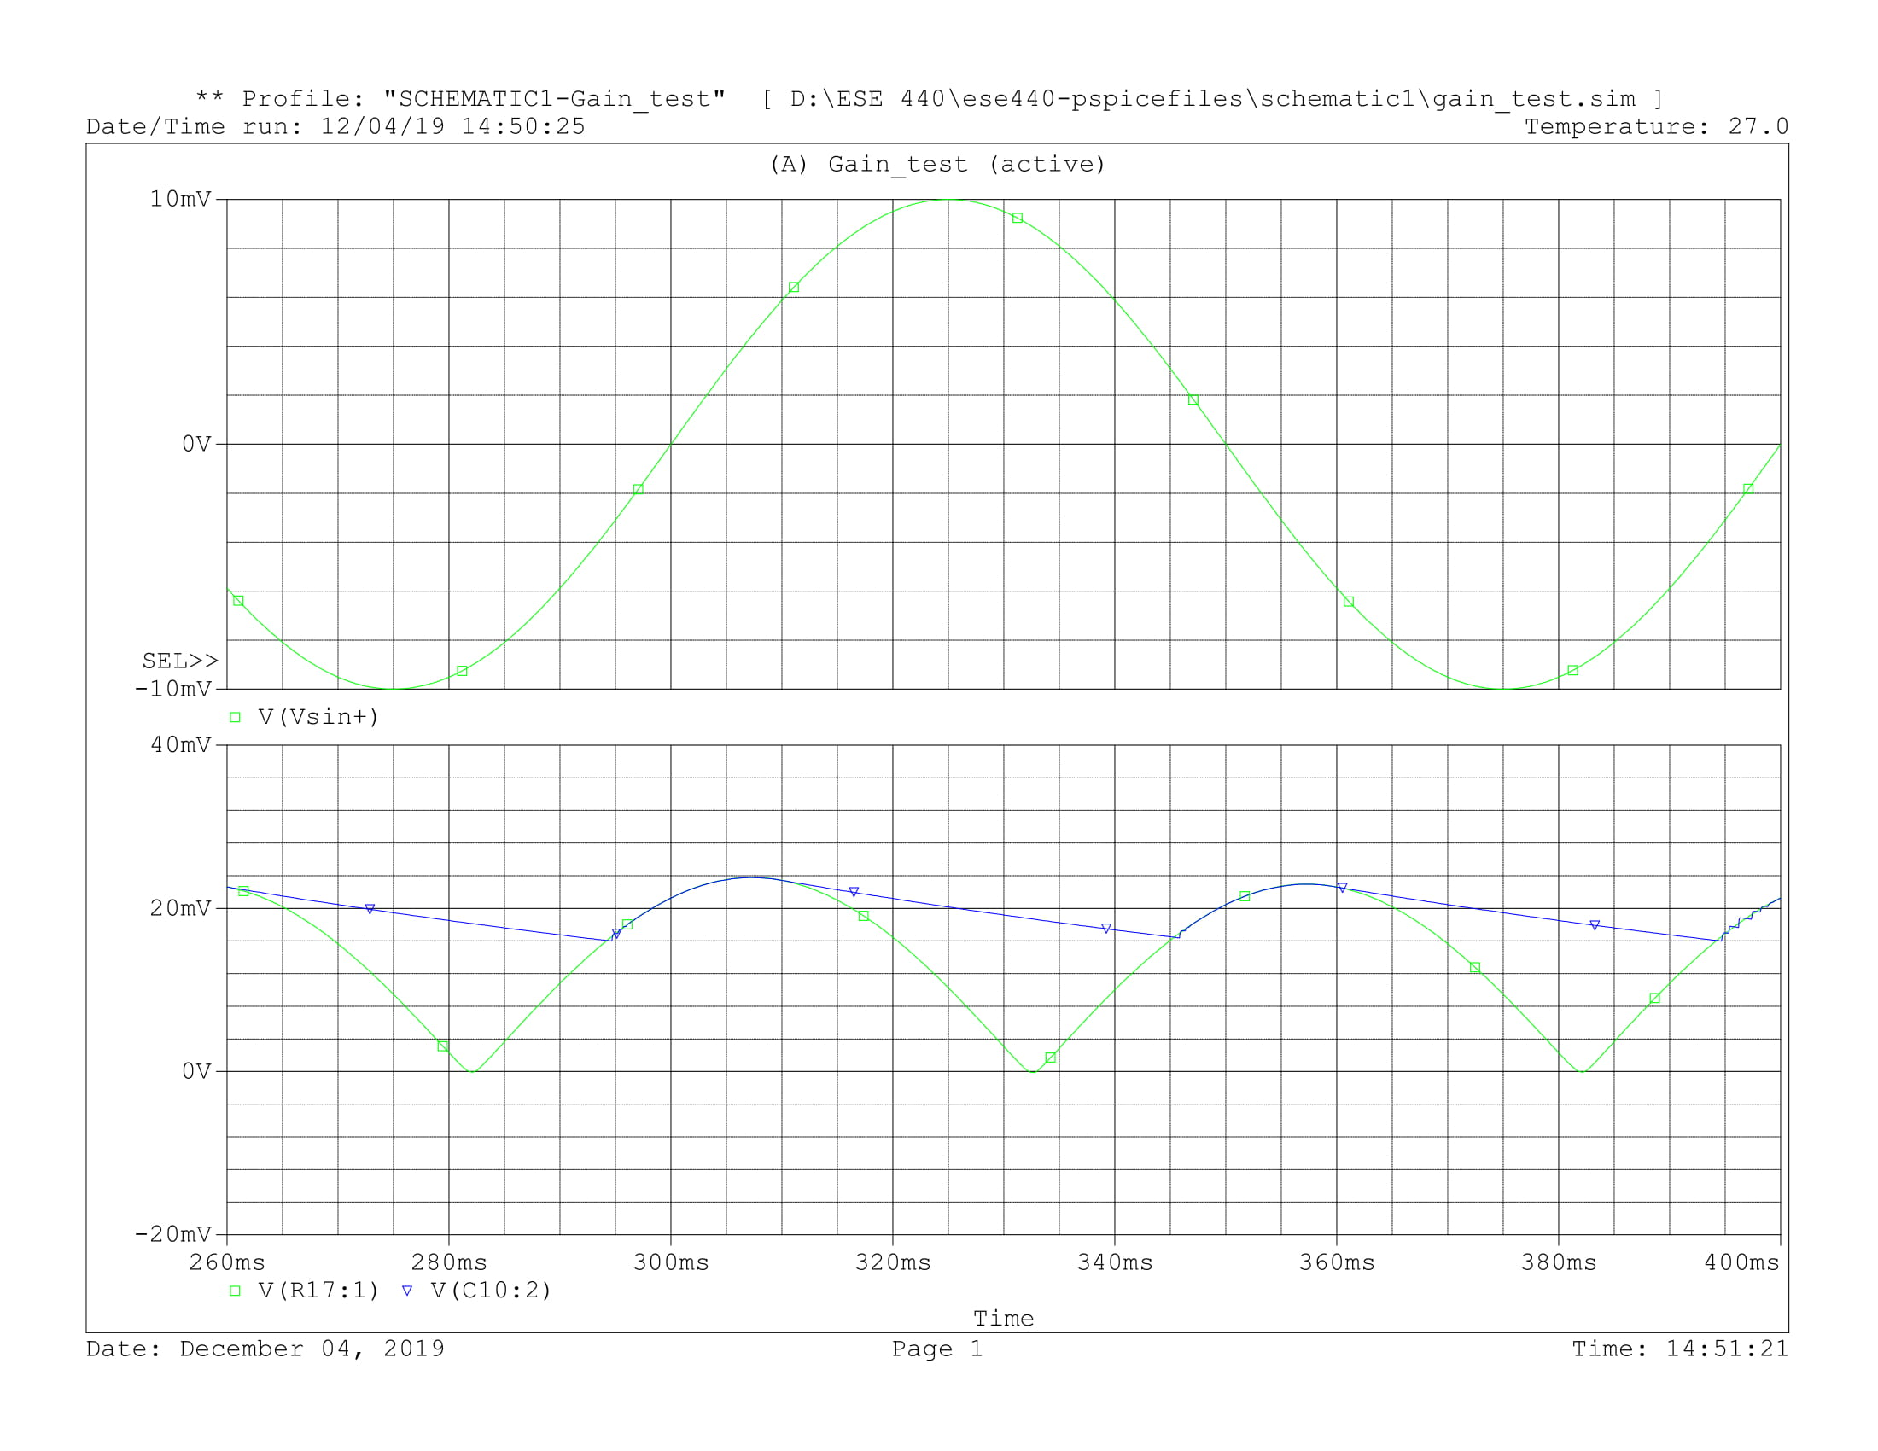

Figure 3: Simulation for 10 Hz input

For an input with frequency of 700 Hz the signal attenuation is not very clear. It’s near the cutoff frequency of 678 Hz and as a result it’d only slightly attenuated. In practise, it’s very difficult to implement a filter that will completely remove all signals above cutoff frequency as signals near cutoff frequency will continue to go through the circuit. On the positive side, EMG signal is not precisely located within our bandpass and signals near 600 Hz are not very common. Because of that the circuit doesn’t have to filter out signals near cutoff frequency.

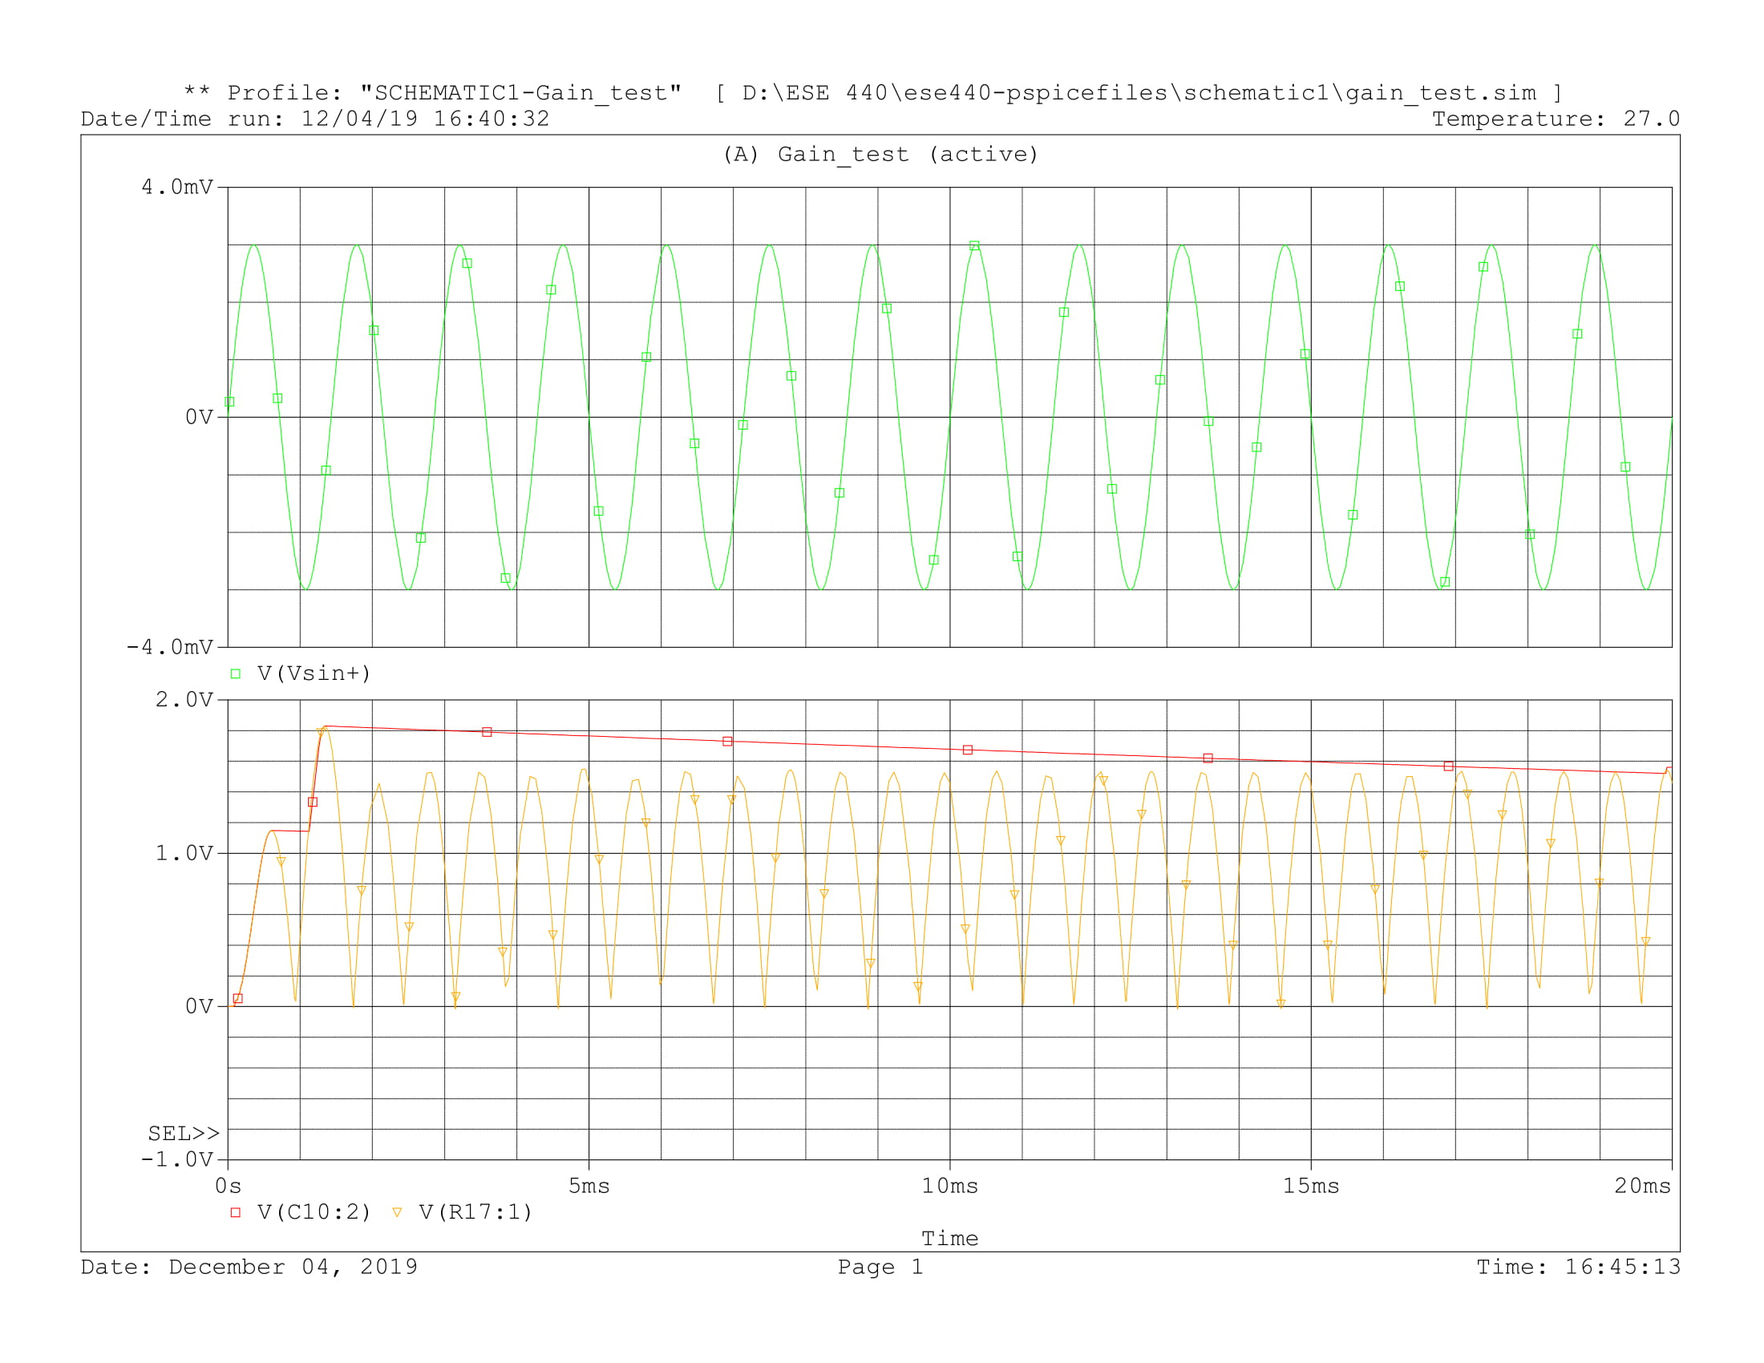

Figure 4: Simulation for 700 hz

For a 5 kHz input the signal attenuation is clear. The output signal is less than 80 mV which is quite small. This frequency is outside EMG rage and represents only noise. Since it’s unwanted signal, it’s important for the circuit to filter these frequencies out.

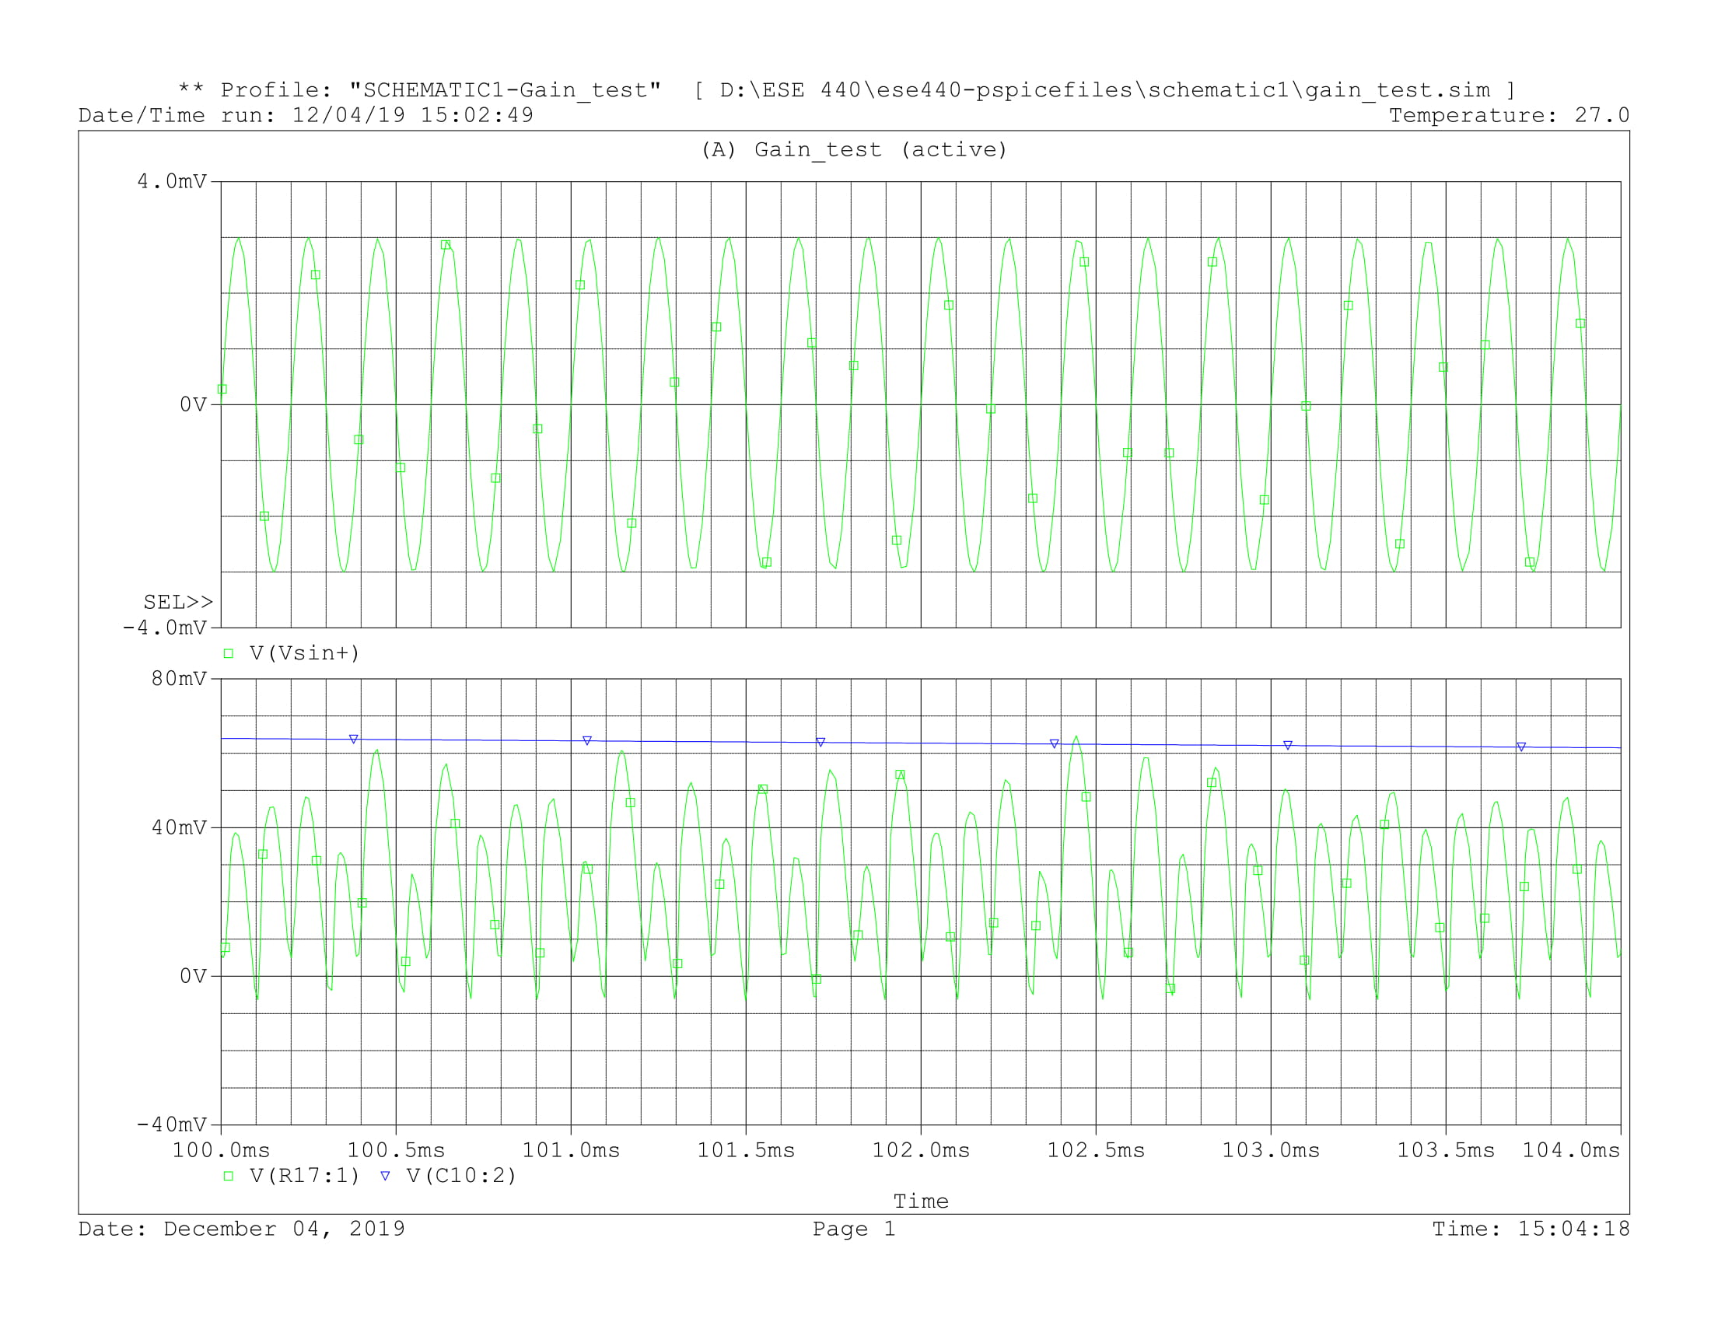

Figure 5: Simulation for 5 kHz

After running simulation in AC sweep mode a bode plot from the filtering stage is obtained (Figure 6). The theoretical bandwidth of the filter is from 45 hz to 710 hz. After running simulation the cutoff frequencies have been measured to be 53 Hz and 678 Hz for highpass and lowpass filters respectively. The roll-off is 40 db/dec since both of the filters are of the second order.

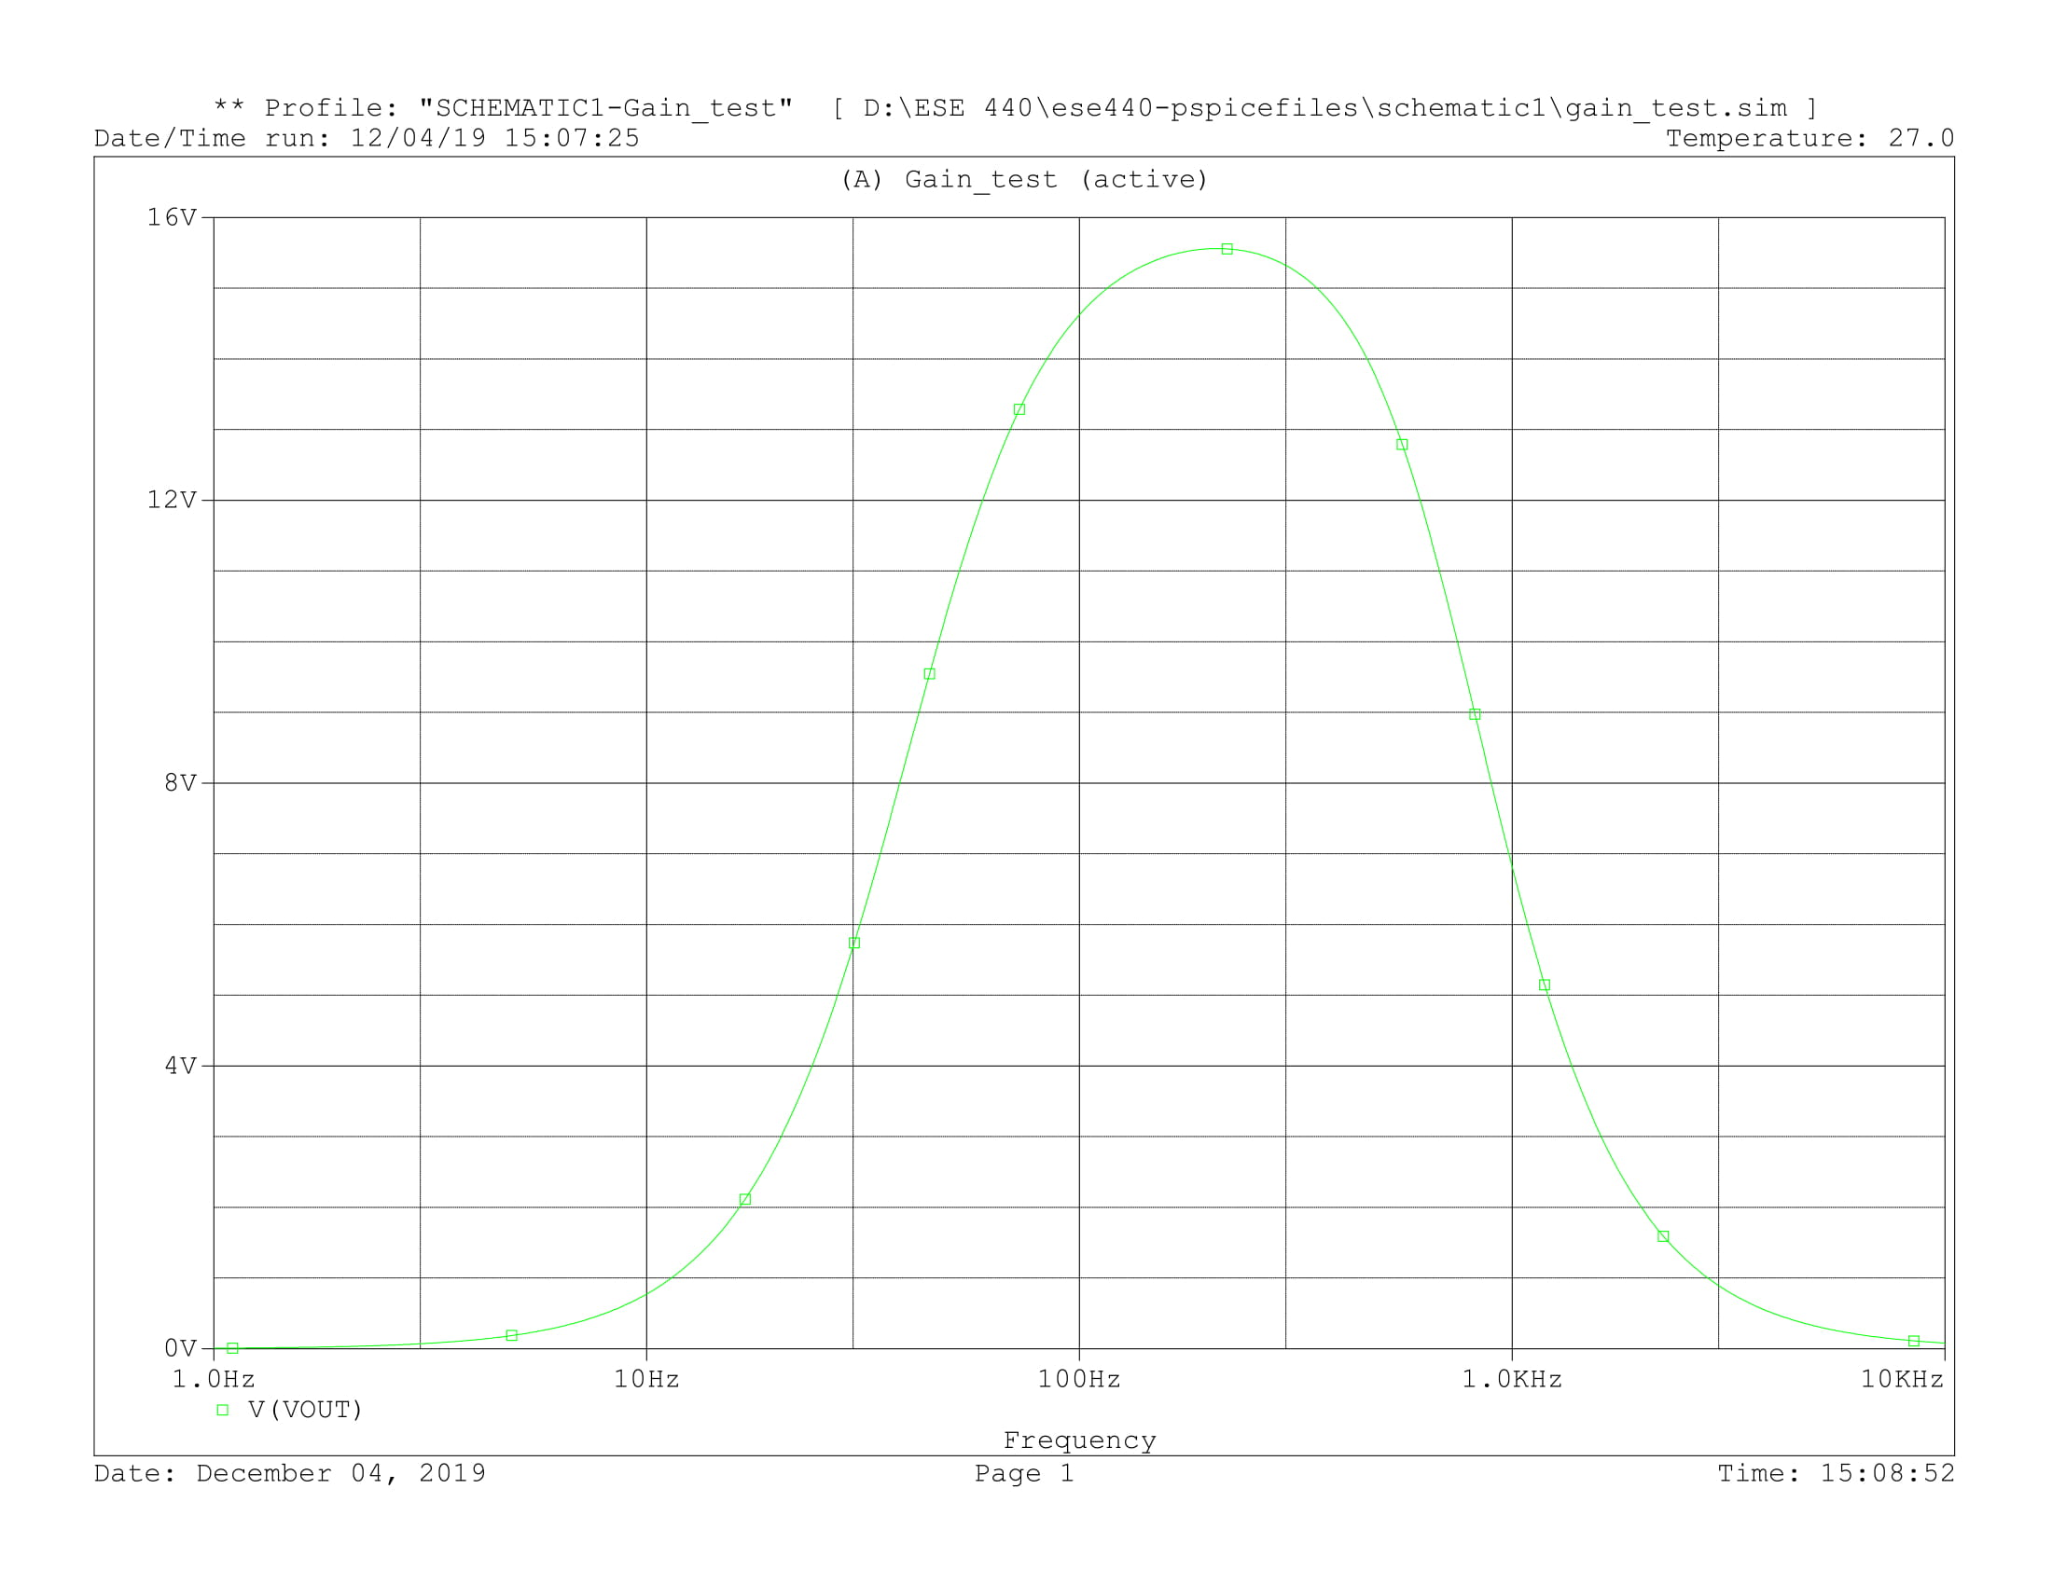

Figure 6: Simulation for AC sweep

After simulating and testing all the parts of the circuit it was recreated in EAGLE (Figure 7). For my project I need to make a prototype with this circuit being a part of it. I’m planning to order a PCB board that I will be able to solder SMD components on

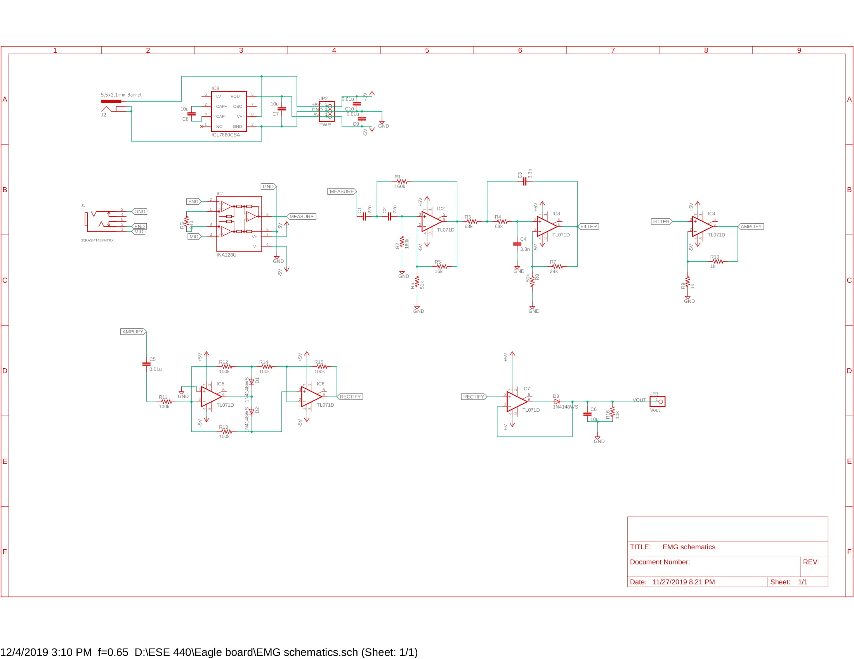

Figure 7: EAGLE schematics diagram

The first version of my board will look as shown in Figure 8. It’s a two layer PCB board with 3.5 jack for the 3 electrodes cable shield, a power jack for a 5V source, DC to DC switched capacitor converter to create a +5V and -5V power supply and the rest of the circuit. It also includes output pin JP1 that can be directly connected to the MCU’s ADC pin for future testing. JP2 is the power pin, with a pin for +5V, GND, -5V, allowing to use an external power supply and test circuit using oscilloscope.

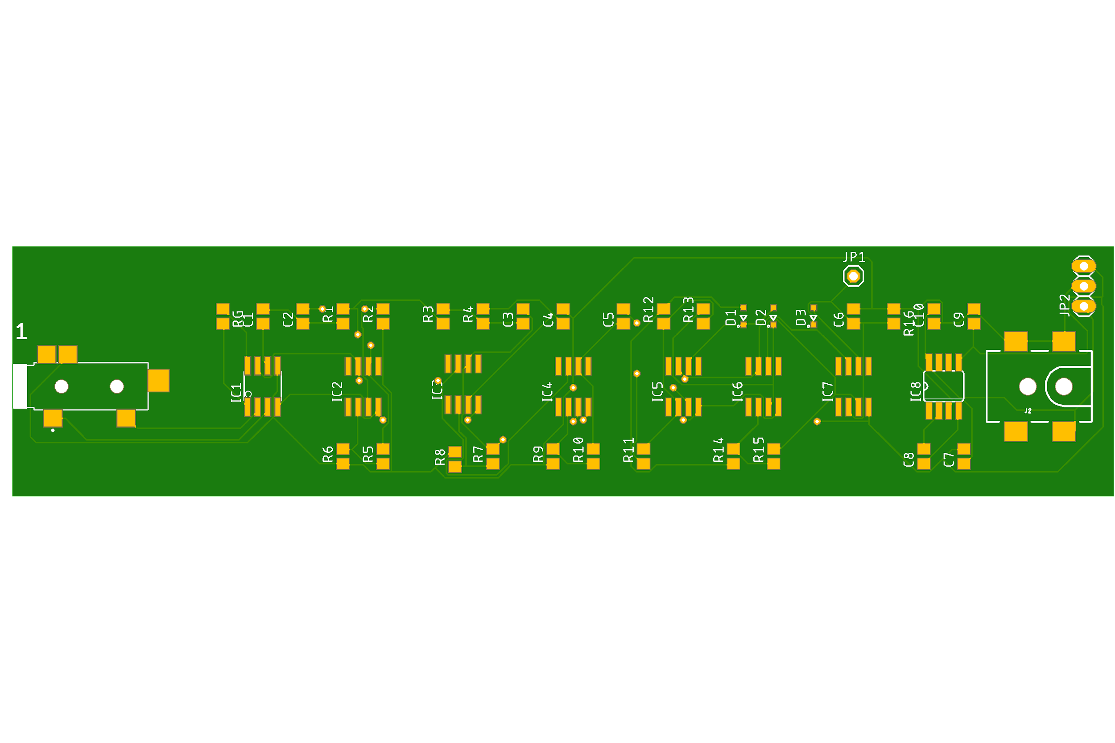

Figure 8: EAGLE board for manufacturing

#### Conclusion and discussion

In the past weeks we have brainstormed and discussed various designs for our prosthetic arm. The goal of our project is to provide an affordable device that’s intuitive to use but also to allow us to learn more about the field of advanced prosthetics and how it impacts people's lives. We have extensively researched different options for parts available to us to create the best product in its price category. In the coming weeks we will build and test a prototype circuit for signal acquisition and processing and then make any improvements we see fit.

#### References

Albus, Zack. *Ultra-Low Power Comparison: MSP430F2x MCUs vs. Microchip XLP Tech Brief*. Texas Instruments, Jan. 2019, [www.ti.com/lit/wp/slay015a/slay015a.pdf](http://www.ti.com/lit/wp/slay015a/slay015a.pdf).

Hines, Eric. “Z-Wave vs Zigbee vs Bluetooth vs Wifi: Which Smart Home Technology Is Best For Your Situation?” *Inovelli*, 19 Oct. 2016, inovelli.com/z-wave-vs-zigbee-vs-bluetooth-vs-wifi-smart-home-technology/.

Garay, Jorge. “An Electromyography Signal Conditioning Circuit Simulation Experience.” *SENSORCOMM,* 2017

Rash, Gregory, “Electromyography Fundamentals”, http://myweb.wwu.edu/~chalmers/EMGfundamentals.pdf

Ray, Brian. “ZigBee Vs. Bluetooth: A Use Case With Range Calculations.” *Link Labs*, 24 Aug. 2015, [www.link-labs.com/blog/zigbee-vs-bluetooth](http://www.link-labs.com/blog/zigbee-vs-bluetooth).

"What's The Difference Between DC, Servo & Stepper Motors?" *Mod My Pi*. 25 Aug. 2013. Web. 7 Nov. 2015.

#### 

#### Appendix A

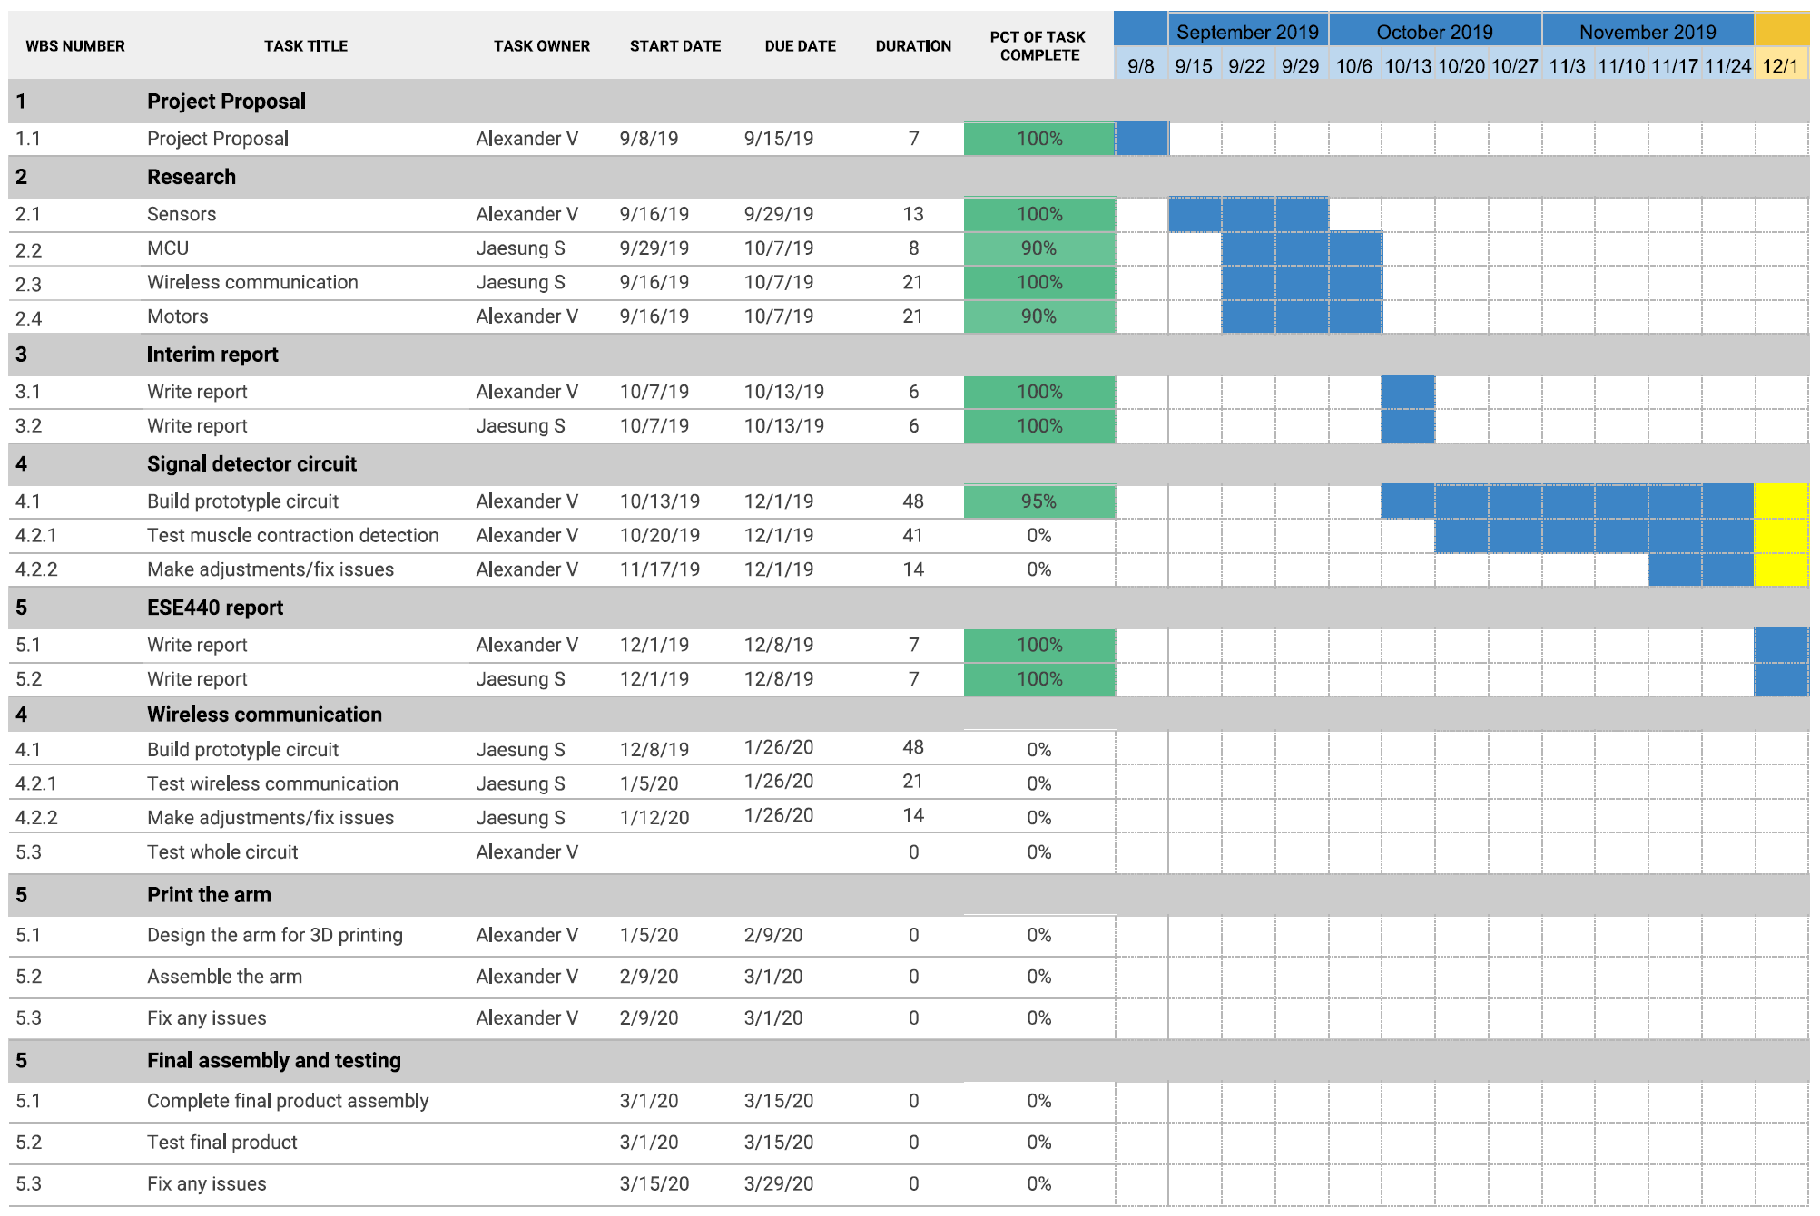

#### Appendix B

Meeting on 10/31

In attendance: Prof. Westerfeld, Alexander Volkov

* Talked about choosing appropriate values for resistors and capacitors for the filtering circuit.
* Placed the order for necessary details on digikey.

Meeting on 10/24

In attendance: Prof. Westerfeld, Alexander Volkov, Jaesung Song

* Updated on the progress of research.
* Discussed the circuitry and components we decided to use.
* Talked about wireless communication device options.

Meeting on 11/7

In attendance: Prof. Westerfeld, Alexander Volkov

* Updated on the progress of circuit design.
* Discussed the circuitry and how to condition signal.

Meeting on 11/26

In attendance: Prof. Westerfeld, Alexander Volkov

* Reviewed initial PCB design and talked about improvements.

Meeting on 12/3

In attendance: Prof. Westerfeld, Alexander Volkov

* Final review of the PCB board before sending order.